**Which Browser to Use**

Of all the important fixes here, using the **Chrome** browser on a computer is the most simple. The program is designed on Chrome and so Chrome has the least amount of problems.

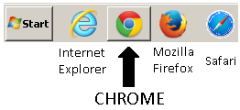If you don’t have it, go to: <https://www.google.com/chrome/browser/desktop/index.html> and download the browser for free.

You can use other browsers, including Safari, but the tech department guy for the textbook said **Chrome** was the best.

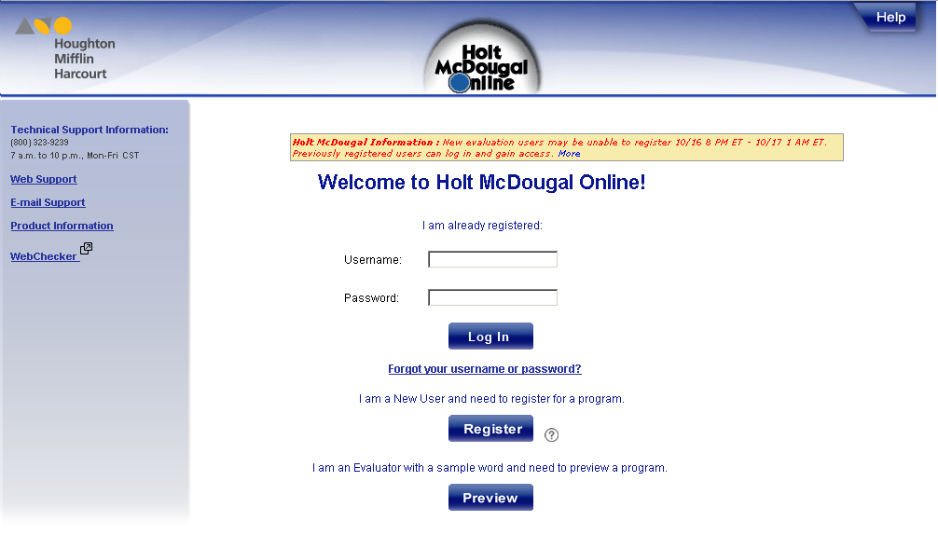**How To Get There**

Go to <http://my.hrw.com> .

Type in your username: s + Student ID + @cusd

ex. s123456@cusd

Type in your password: s + Student ID + !

ex. s123456!

HINT: The “s” must be lower case

**Dashboard Navigation**

Once you are logged in, this is your home screen:

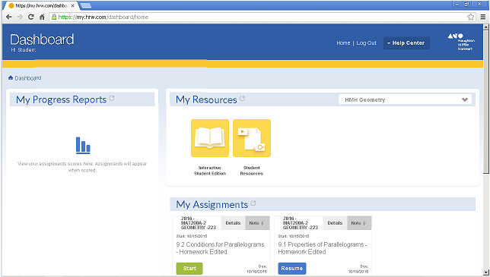You can access an online interactive version of the book and homework by clicking the yellow “Interactive Student Edition”

You can access pdf versions of the textbook by clicking the yellow “Student Resources” icon

Assignments are listed below the Resources tab and by clicking on the green button labeled “Start” you can begin.

**WHY DIDN’T MY HOMEWORK START?!**

Depending on your browser settings, you might not see your homework when you click on the “Start” button. Chances are, this is because you have **blocked pop-ups.** All the homework in this book pops up in a new window and you will need to tell your browser to allow it.

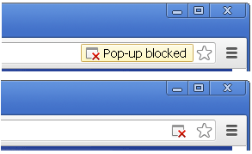**ON WINDOWS with CHROME:**

On **Chrome**, the first time you click, it will show a message in the upper right-hand corner. The message reads “Pop-up blocked” and after a few moments it will disappear. Then it will be replaced with just the little window icon with a red x.

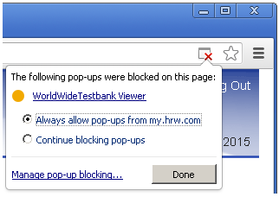If you right-click on the little red x window, you will be shown a menu that has the option to “Always allow pop-ups from my.hrw.com”. You want to select that and click “Done”.

From now on, you should be able to access your homework.

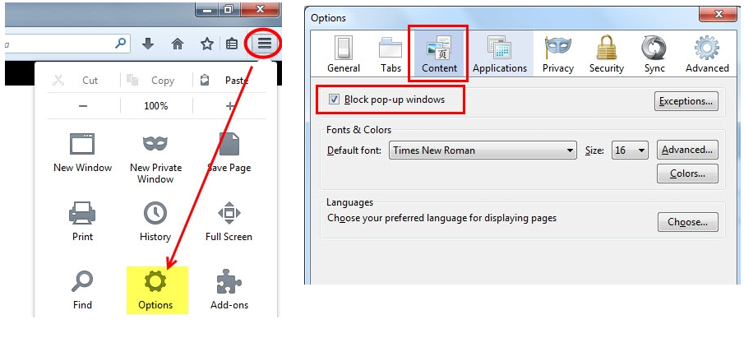

**ON WINDOWS with MOZILLA FIREFOX:**

Click the settings tab in the corner, select content and uncheck “Block pop-up windows” (see diagram on right)

**ON WINDOWS with INTERNET EXPLORER:**

The message for the popups appears at the bottom of the screen. Click options and allow.

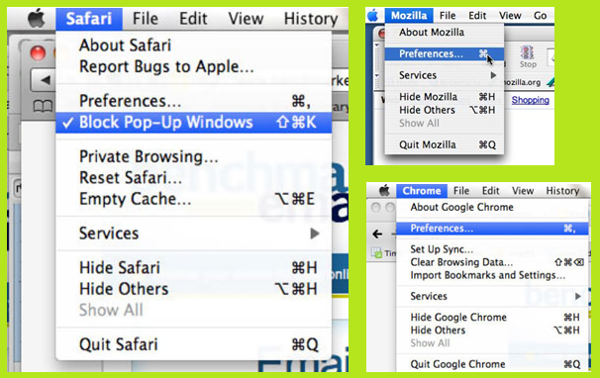**ON MAC:**

Click on the upper left corner by the APPLE symbol on the name of the browser you are using. For Safari, just uncheck the “Block Pop-Up Windows” option.

For other browsers, after selecting them from the menu, choose “Preferences” and an option to allow popups will be there.